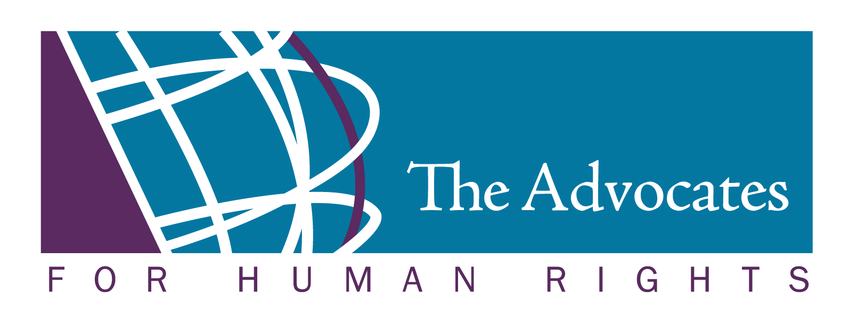

Agency & Immigration Court Contact Information

|  |
| --- |
| **USCIS - Chicago Asylum Office (AFFIRMATIVES)**  181 W. Madison Street, Suite 3000  Chicago, IL  60602  312-849-5200 |

|  |
| --- |
| **DHS/USCIS – Nebraska Service Center (for Initial Removal Asylum Filing)**  Please confirm mailing addresses at [www.uscis.gov](http://www.uscis.gov) for all other applications (work permit, family petitions, permanent resident applications).  Email: ncscfollowup.nsc@dhs.gov |

|  |  |
| --- | --- |
| For Regular Postal Mail  Department of Homeland Security  Citizenship & Immigration Services  Nebraska Service Center  P.O. Box 87589  Lincoln, NE 68501-7589 | For Commercial Deliveries, i.e. Fed. Ex.  Department of Homeland Security  Citizenship & Immigration Service  Nebraska Service Center  850 S. Street, P.O. Box 87589  Lincoln, NE 68508 |
| **Office of Chief Counsel (“OCC”)**  Location and Mailing address  Office of Chief Counsel  1 Federal Drive, Suite 1800  Fort Snelling, MN 55111  Phone: (952) 853-2970  Fax: (612) 313-9073 |  |
| **Immigration Court**  Executive Office for Immigration Review  Fort Snelling Immigration Court  1 Federal Drive, Suite 1850  Fort Snelling, MN 55111  Phone: (612) 725-3765  Fax: (612)725-3716  Information Line: (800) 898-7180  [www.justice.gov/eoir](http://www.justice.gov/eoir) | **Immigration Judges**  Ryan R. Wood, Assistant Chief Immigration Judge  M. Audrey Carr  Katherine L. Hansen  Sarah Mazzie  Monte G. Miller  Brian Sardelli  **Court Administrator**  Elizabeth Baldwin  [elizabeth.baldwin@usdoj.gov](mailto:elizabeth.baldwin@usdoj.gov) |

|  |
| --- |
| **Board of Immigration Appeals (“BIA”) [NOTE NEW ADDRESS AS OF 10/01/13]**  BIA  Office of Chief Clerk  5107 Leesburg Pike #2000  Falls Church, VA 20530-0001  Phone: (703) 605-1007  <http://www.justice.gov/eoir/contact.htm> |
| **Federal Appeals Court**  Eight Circuit Court of Appeals  Office of the Clerk  Thomas F. Eagleton Courthouse  Room 24-329  111 South 10th St.  St. Louis, MO 63102  Phone: (314) 244-2400 |
| **Freedom Of Information Act Form (“FOIA”) for USCIS**  U.S. Citizenship and Immigration Services  National Records Center  FOIA/PA Office  P.O. Box 648010  Lee’s Summit, MO 64064-0810  Fax: 816.350.5785  Email: [uscis.foia@dhs.gov](mailto:uscis.foia@dhs.gov) |
| **Freedom Of Information Act Form (“FOIA”) for USVISIT**  US-VISIT FOIA Officer Department of Homeland Security Washington, DC 20528 Phone: (202) 298-5200  Fax: (202) 298-5201  Email: [US-VISIT-FOIA@dhs.gov](mailto:US-VISIT-FOIA@dhs.gov) |
| **Freedom Of Information Act Form (“FOIA”) for CBP**  <http://cbp.gov/xp/cgov/admin/fl/foia/> |